My Games in The World Championship ‘99.

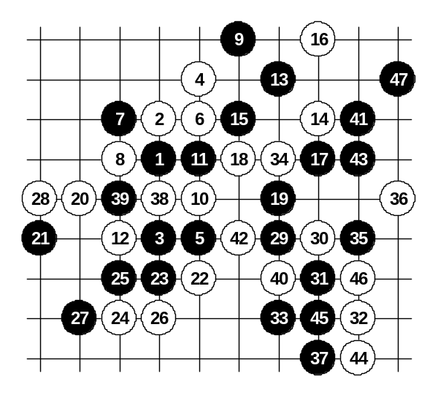
Meritee – Nishizono, 1:0, 47, D11
The game with Nishizono was a big question for me because I had never played with him before. Previously, we had just heard about each other, but not played, so the game was quite nervous therefore. The opening was played quite fast. I had decided to play as black in this tournament as many times as possible because previously people knew Meritee likes to play as white, so I had to change my tactics to surprise my opponents. As a result, I played 10 times as black and once as white in WC’99.
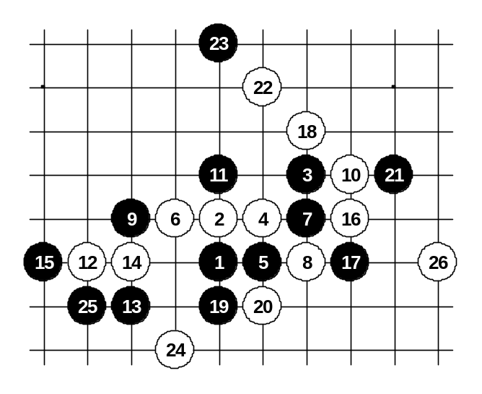
The 14th move surprised me. I thought people had given up playing this because black advantage is too obvious there. Anyway, I was a bit concerned about his possible surprises. I continued standard pattern up to 25. The 26th move should not be good according to my old analysis. So I replied 27 immediately. The 28th move was a big surprise to me, especially because he played it so fast. At first I thought it was his home analysis, so I took a long time to check the variants. But soon I realised the disadvantage of that 28th move – although it is sharp move and makes promising position for white above, the key point 38 will remain open and therefore black will have one extra open line on the right side. So, whenever white plays at 38 then the 39-point will give black winning power on the left side. In this game, black even didn’t need the left side win – the right side happened to be powerful enough. Therefore, I think that 26-38 is much better – it will block the open diagonal line towards right side without giving winning power to black on the left.

Kozhin – Meritee, 0:1, 26, D3
This was my only game as white and it happened to be so because Kozhin changed the color in the d3 opening that I had set. As I had laptop PC with renju database with me in Beijing, I used special preparation for every opponent by studying their old games. In the database I had seen Kozhin playing this position once as white, so I was expecting some kind of development from him as black. But I wasn’t sure in which move the surprise will come. 19! That was a sharp move. I spent lots of my time to find any satisfying answer to this sharpness. I had to use some of my power above for defence though. 24 – position had become stable. 25?? Even the great players like Kozhin slip in their deep thinking.
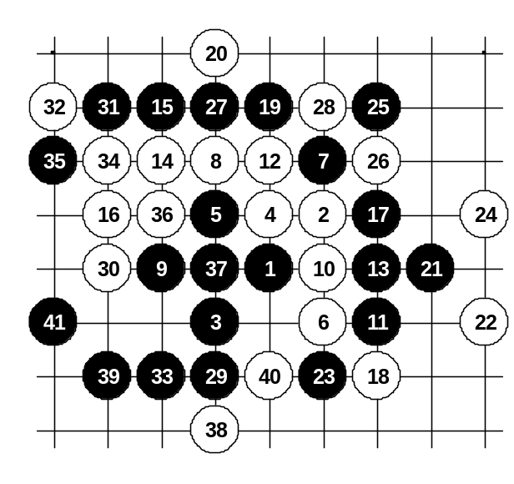

Meritee – Sinyov, 1:0, 41, I11
Last times, Sinyov had tried gambling variants on me, so I was expecting something unusual. The opening i11 was a surprise indeed. Being faithful to blacks, I swapped.
A funny thing happened – Sinyov, being so nervous, chose one of the 5th moves I offered and pushed the clocks without playing his own white stone. None of us knew what to do, so we asked the referee committee to solve the situation. They had long long discussion which wasn’t doing any good to us – the long waiting made us both more nervous. Anyway, finally the game continued. When he had played 14th move, I suddenly remembered something that Ants had told me in airplane while travelling from Stockholm to Beijing. He told he had seen Stefan Karlsson winning quite fast after that 16th move. As we were only talking about it without using any board, I could only understand that it was direct attack from 17th. So in the game with Sinyov I took a long time to search for the ways for winning attack. Finally, I realized there is an idea to gain the power to lower side by the attack till 23rd move. The 25th and 27th moves are necessary too. But then I had to think again: 29-29 or 29-30? Both were strong moves, but I didn’t want to make a move without being 100% sure. So I spent much time here too. If 29-30 then 30-29 and I couldn’t see the sure win for black. So I focused at thinking of 29-29 and I was happy to realize soon that it will give sure win for black. Later, when the game was over, I checked the database – Stefan had played against Reims 29-30, but Reims played another move than 30-29, so black won there easily too. Perhaps black has sure win for both 29th moves, who knows.

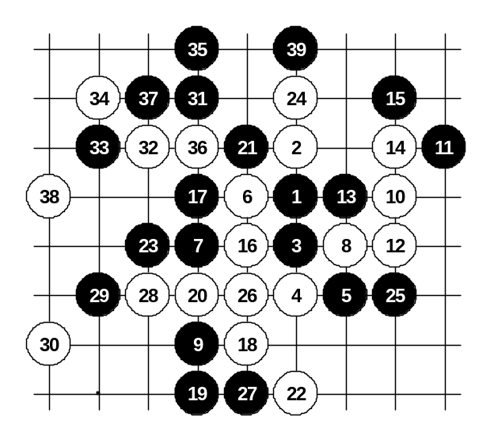
<<Meritee – Soosõrv, 1:0, 39, D8
I wished I could set the opening myself, but according to the tournament pairing he had the right to set opening. That was advantage for him, I think, because we know each other too well. The opening d8 surprised me a little. I was expecting i11 as he had played against me in past. Anyway, I had prepared this 21st move in case he would come up with d8 opening. It seemed to surprise him because he couldn’t find any good plan for white – first he tried active play with 22 but then decided to defend 26…30. The 31st move is black win.

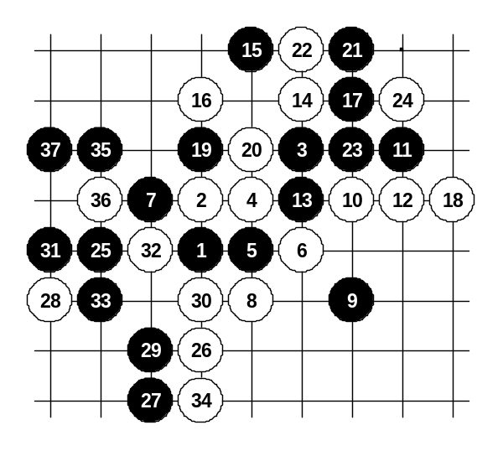
Meritee – Makarov, 1:0, 37, D3
This game was also one of my preparations. Before the game, I was in my room, checking database with laptop PC. I noticed that he likes that 6th move a lot. So I had some time to prepare something for Makarov. The 9th move was a little surprise for him, I think. 10, 12, 14 – an active plan. 15! Calm move. It seems that white can’t have any good continuation. 16 was good defence move. I couldn’t be sure what to do. I tried 17th move to the right side. 18 – good move again!
I was beginning to worry that I can’t win that easily anymore. I tried to make things complicated by 19th move but his 20th was still correct. I realized I can’t win here by force. Had to trick him somehow. 23!? – bluff. The analysis after game showed that black can’t win up in the corner. After 25th move another white mistake followed – 26?? Now there was already easy way to black victory. I think Makarov couldn’t stand the pressure of that game too long, so he slipped by the end.

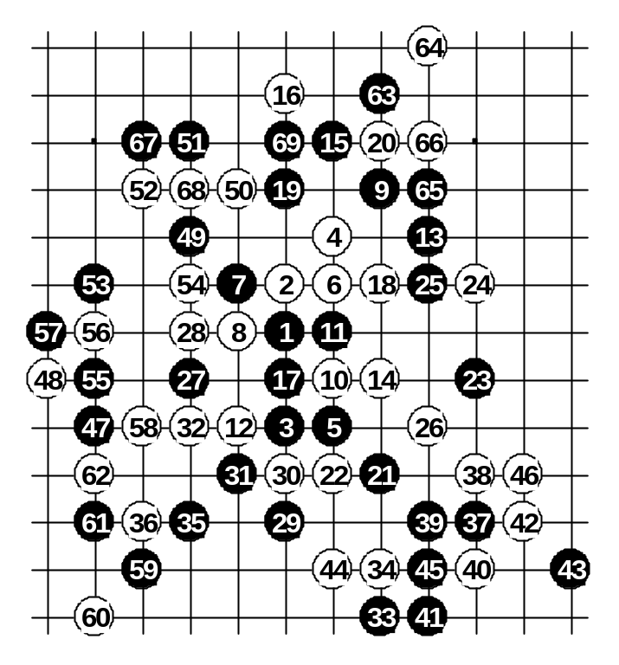

Meritee – Sushkov, 1:0, 69, D11
This game was perhaps the most unprepared one. I expected Sushkov to play something odd, so I didn’t check the main variants specially for him. He played the traditional 18th move. He gave up all his chance to get any activity of his own in future, he just let me attack continuously. But I admit I didn’t attack well in this game. I tried to make connections between lower and upper side through the left side, but he blocked all my attempts. But such blocking gave me really good chances for attack below. He was lucky - miraculous defense kept the game still going on. By 46th move Black attack had failed. I still continued game, I even rejected his draw offer. I tried last chances on the left side. By then I was already in time-trouble. We both rushed with making moves. Suddenly he missed the simplest threat and 69 was the beginning of simple VCF. I can call this game to be lucky to me – the fair result would have been draw. I guess my mistake was the poor preparation before that round.

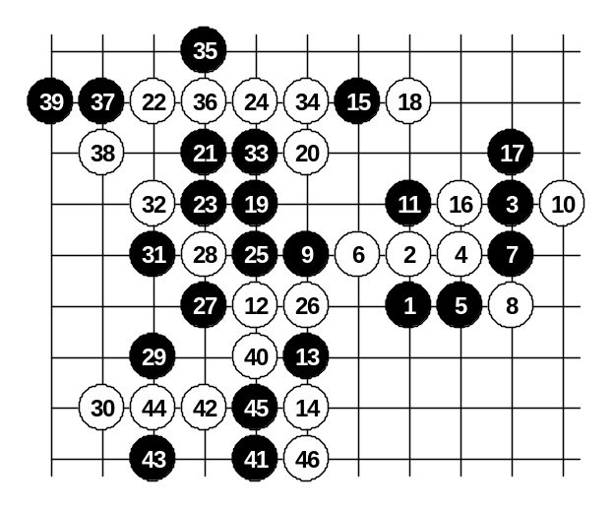
Meritee – Zhang, ½:½, 46, D3
This game doesn’t require much comments. I become the victim of underestimation here. I expected Zhang to make mistake which he didn’t. I attacked continuously in this game, trying hard to win. Even though people had given up this 23rd move because they thought 24 is a decent block, I still had faith in black attack. 27, 29, 31 – very promising. But there was always one block that ruined my plans. He played well, I admire his calm defense. After 46th move he offered a draw. Although I thought I will continue fight below with move h4 but it was powerless, I accepted the draw offer and had some rest before the next round in next day.

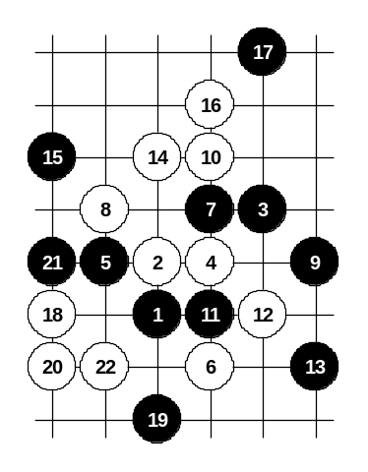
Meritee – Hayakawa, 0:1, 22, D3
This game was a total disaster. Being convinced that I have good position as black even though white was attacking temporarily, I became really careless. I was thinking of my future developments and so I tried sharp 19th move – let the white attack, but remains all good power for black on the right side and below. But oh silly of me – I forgot the simple 3x3. It was same kind of mistake as Kozhin made against me in the 2nd round, missed the simple threat.
The best solution for black would have been 19-e8, after which black becomes powerful on both left and right side. I think I had problems with concentration in that round. Hayakawa used this situation in the best way.

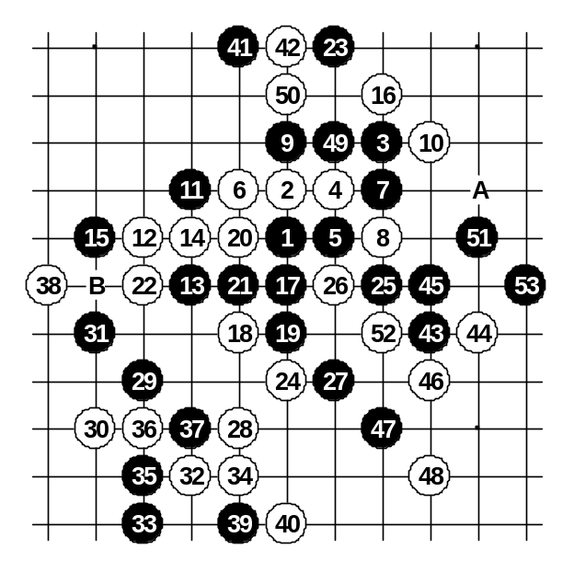
Meritee – Sagara, 1:0, 53, D3
In order to avoid the same mistake as previous WC (I lost 2 games in one day), I decided to play calm and carefully against Sagara. I decided to play the most peaceful opening – d3.
His 16th move was different than I had played against Kozhin in the 2nd round. The 17th seemed to be the best move. I hoped he would go attacking as white or do something active, but he didn’t. He just defended below. That made my game much harder. Perhaps 19 was not so confident move. Anyway, after 22nd move I was already in trouble. First I thought I almost can win with 23-27 but then I realized that excellent 24-A will cut my VCF. Therefore, I decided to defend instead, 23-23. Now he stopped my line below, of course. 28 !! It seemed white is going to win this game soon. But I continued fighting hard. I didn’t just block, but I blocked in the most active way I could, in order to create extra power for black. The 34 was not the best idea. The 35 and 37 followed with good construction! The 38th move showed his weakness. If he was afraid of my connections between left side and upper side, why didn’t just block in upper side? Suddenly, black was back in business, attacking all over! It seems he had no power to concentrate – 46 was his final mistake. He should have played 46-B or 46-49 and then 48-46. But he didn’t notice the black idea and so he simply stopped with 46-46. Amazing game. Sagara is the great player but he was not in good condition in this tournament.

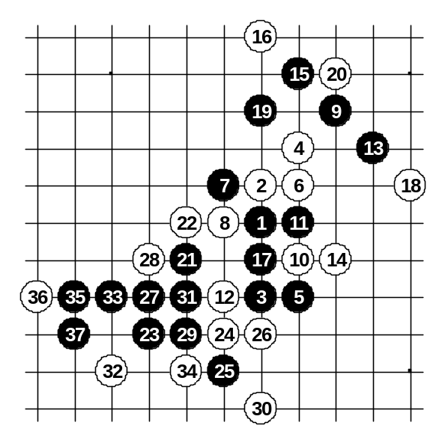
Meritee – Karlsson, 1:0, 37, D11
This game was a key one. I wanted to win this so much in order to secure the first place before the last round.
Therefore, in spite of the late time in last night, I continued analysing till almost next morning. I knew Stefan will set the d11 opening and will probably play this 18th move because he had been successful twice as white in WC’99. My sleepless night had good contribution – Stefan played exactly what I had expected. He made another 26th move. But I had studied every kind of 26th here, so I played quite fast. The 27th move was the beginning of sure win.
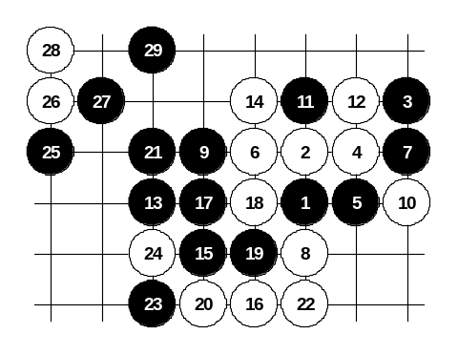

Meritee – Hasegawa, 1:0, 29, D3
Last round. Just as in previous WC, I met Hasegawa in the last round. Many people joked about the repeating of the history – the leader of the WC will lose in the last round to 2nd place player. I didn’t want this joke to become true. So I prepared seriously for the last game even though I had already secured the first place.
I set the d3, he kept whites as I had expected. According to my preparations, I expected him to come into that variant with 12th move. The 14th was the first surprise. I thought he will play as usual – 14-15, after which the variant becomes unclear. The move 14-15 was already played several times in this WC. As Hasegawa said after game, the 14th was Nara’s suggestion. So, Hasegawa was playing it without being certain about the following. He played the 16th move quite fast. Frankly, he didn’t expect the black will go attack straightforward with 17-17. Anyway, after 1 hour of thinking I found sure win here. A big relief. I played moves up to 29 and he gave up. This game can be divided into the category “the opening disasters”. Such disasters happen even to strongest players.

